UNIT12. WHAT DOES YOUR FATHER DO?

Ex 1: Put a suitable word under each picture- Điền 1 từ thích hợp dưới mỗi bức tranh .

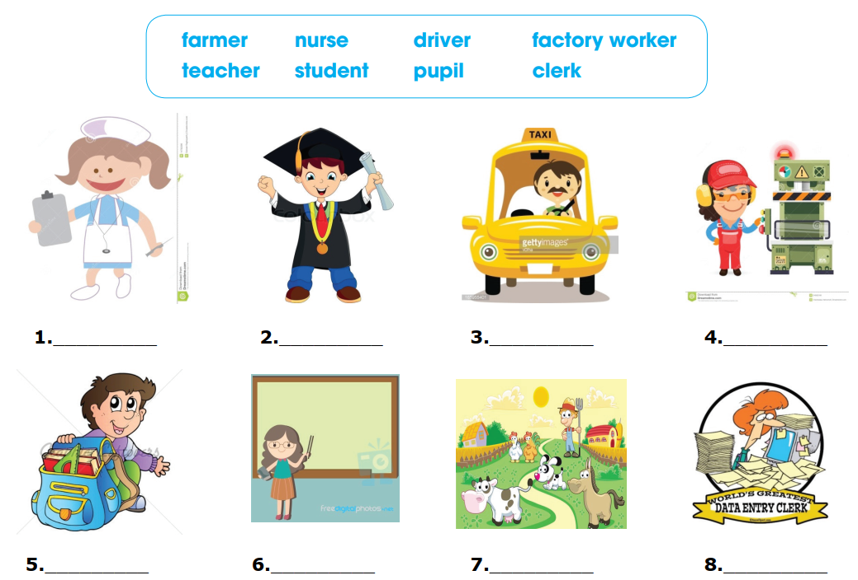

Ex 2: Unscrambled words – Sắp xếp các chữ cái để được từ đúng

a. oiphslat …………………………… | f. lippu ……………………………
b. korw …………………………… | g. chteaer ……………………………
- c. dleif …………………………… | h. seurn ……………………………
d. rytocaf …………………………… | i. loochs ……………………………
e. ffcioe …………………………… | J. mraf ……………………………

Ex 3: Read and match – Đọc và nối

1. What does your father do ? |  | a. He works in the factory
2. Where does a worker work ? |  | b. works in a field.
3. Does he like his job? |  | c. teacher in a primary school.
4. A farmer |  | d. He is a worker.
5. My aunt is a |  | e. Yes, he does.

Ex 4: Reorder these words to make correct sentences– Sắp xếp các từ thành câu đúng.

1. uncle / do ? What / does / your
……………………………………………………………………………………
2. does / Smith / Where / Mrs / work ?
……………………………………………………………………………………
3. doctors / The / nurses / the / hospital / work / in / and
……………………………………………………………………………………
4. a / student / of / Oxford / My /university / sister / is
……………………………………………………………………………………
5. taxi / drives / A / taxi driver / a
……………………………………………………………………………………

Ex 5: Each sentence has one mistake. Underline and correct it. Mỗi câu có một lỗi sai. Gạch dưới lỗi sai và sửa lại cho đúng.
1. That are my favourite drink.
……………………………………………………………………………………
2. Would you like an bread ?
……………………………………………………………………………………
3. Where do your little sister learn ?
……………………………………………………………………………………
4. My grandpa and my grandma is farmers.
……………………………………………………………………………………
5. I has breakfast at seven o’clock.
……………………………………………………………………………………

Ex 6: Read the passage and write T (true) or F (false). There is one example – Đọc đoạn văn và viết T ( nếu câu đúng) hoặc F (nếu câu sai). Có một ví dụ .
Hello everyone. My name is Helen . There are five people in my family. They are my grandma, my grandpa, my parents and me. We all have different jobs. My grandpa is a worker in a factory. My grandma is a housewife. She works at home. My father is a soldier. My mother is a teacher of English. She teaches in a primary school . And I am a pupil. I’m in the fourth grade at Press Primary School. I love my family very much.
 | True | False
1.Her name is Helen. | T
2.There are four people in her family.

3.Her grandpa is a worker in a factory.

4.Her grandma is a nurse.

5.Her dad is a police.

6.Her mother is a teacher of English.

7.Helen’s mother teaches in a primary school.

8.Helen is a pupil.

9.Helen studies at Press primary school.

10.Helen doesn’t love her family.

