UNIT 13: WOULD YOU LIKE SOME MILK?

Ex 1: Put a suitable word under each picture- Điền 1 từ thích hợp dưới mỗi bức tranh .

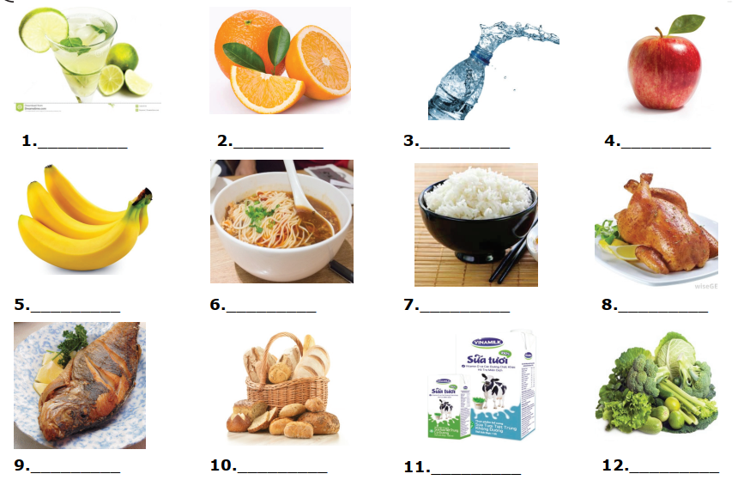

Ex 2: Circle the odd one out – Khoanh tròn từ khác loại.

1. | a. drink | b. beef | c. fish | d. meat
2. | b. tomato juice | b. lemonade | c. apple juice | d. food
3. | a. rice | b. noodles | c. spaghetti | d. lemonade
4. | a. cook | b. some | c. draw | d. drink
5. | a. fish | b. pork | c. beef | d. ice cream
6. | a. clerk | b. field | c. factory | d. office
7. | a. vegetable | b. breakfast | c. lunch | d. dinner
8. | a. bread | b. noodles | c. hungry | d. fish

Ex 3: Reorder these words to make correct sentences– Sắp xếp các từ thành câu đúng.

1. you / like / Would / some / coffee?
……………………………………………………………………………………
2. favourite / What / is / food ? / her
……………………………………………………………………………………
3. is / rice / Her / favourite / food
……………………………………………………………………………………
4. a / of / you / like / Would / bowl / noodles ?
……………………………………………………………………………………
5. have / you / breakfast / do / What / for ?
…………………………………………………………………………………………
6. is / drink / your / favourite / What ?
…………………………………………………………………………………………
7. mother / home / late / goes / evening / the / in / My
…………………………………………………………………………………………
8. drink / is / juice / favourite / My / orange
…………………………………………………………………………………………

Ex 4: Write questions for the underlined parts – Viết câu hỏi cho phần gạch chân.
1. My father is a taxi driver.
…………………………………………………………………………………………
2. Doctors work in hospital
…………………………………………………………………………………………
3. I love chicken
…………………………………………………………………………………………
4. Mai gets up at six o’clock in the morning
…………………………………………………………………………………………
5. Hoa’s brother’s favourite drink is lemonade
…………………………………………………………………………………………

Ex 5: Read the passage and answer questions – Đọc đoạn văn và trả lời câu hỏi.
LINH’S FAMILY’S BREAKFAST
Mum and dad have orange juice, toast and coffee for breakfast. I only have a glass of milk and some bread. My mum always tells me to eat more, but I don’t have enough time. At the weekend, we always have a big breakfast with rice, some meat and cucumber salad. Dad makes it. Mum thinks the breakfast is very good.

1. Who has toast for breakfast?
…………………………………………………………………………………………
2. Does Linh have bread for her breakfast?
…………………………………………………………………………………………
3. Why doesn’t Linh eat more?
…………………………………………………………………………………………
4. When does the family have big breakfast?
…………………………………………………………………………………………
5. Does Linh’s mum think the big breakfast is awful?
…………………………………………………………………………………………

