REVIEW 4
Grade 4 – Supplementary Document Covid -19

Ex1: Circle the odd one out- Khoanh tròn từ khác loại.
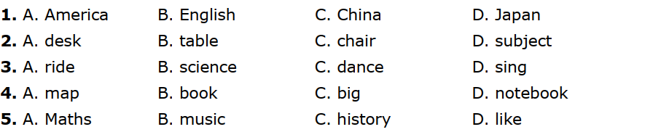

Ex 2: Choose the word which the underlined part is pronounced differently from the other- Chọn từ có phần gạch chân phát âm khác với các từ còn lại.
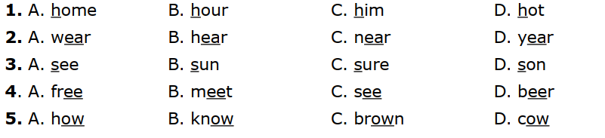
Ex3: Read and circle the correct word- Đọc và khoanh tròn từ đúng.
1. What does your sister looks like/look like?
2. Mrs Hanh is tall and thin/thinner.
3. Who is fatter/fat, your father or your grandfather?
4. Hung is strong/stronger than his baby brother.
5. They are weak/ weaker and we are strong.

Ex4: Put the words in correct sentences- Sắp xếp từ thành câu.
1. elephants/ because/ they/ I/ bulky./ like/ are/ don’t
……………………………………………………………………………………
2. apple juice?/ like/ some/ would/ you/
……………………………………………………………………………………
3. join/ School/ the/ I’m/ going to/ Lantern Parade/.
……………………………………………………………………………………
4. you/ Ho Chi Minh City?/ When/ come/ back/ did/ from/
……………………………………………………………………………………
5. with my/ play football/ friends/ on Sunday./ I often/
……………………………………………………………………………………
6. my uncle/ weekend/ my house./ Last/ stayed at/
……………………………………………………………………………………
7. T-shirt/ wearing/ and/ He’s/ jeans./ a/
……………………………………………………………………………………
8. and mountains/ country./ in my/ a lot of rivers/ There are/
……………………………………………………………………………………
9. usually stay/ Do they/ by the sea? / in a small house/ or flat/
……………………………………………………………………………………
10. their friends/ what do/ like to/ talk/ about?
……………………………………………………………………………………
Ex5: Read passage and complete the below table – Đọc đoạn văn và hoàn thành bảng dưới.
There are two girls in the park. They are Lily and Nana. Lily’s hat is purple with red and green strawberries. Her dress is purple and her apron is orange. She is wearing dark-green socks and brown shoes. Her hair is brown and she has nice blue eyes.
Her friend, Nana, is wearing a hat. Her hat is green with a yellow butterfly, her hair is yellow, her dress is orange with pink flowers. Her shoes are green. The grass is green too.

Lily | Thing | Colour
 | hat
 | dress
 | socks
 | shoes
 | hair
 | eyes
Nana | hat
 | hair
 | dress
 | shoes

Ex6: Read and answer the questions – Đọc và trả lời câu hỏi.
This is Trang. She is a young girl from Ho Chi Minh City. She is 11 years old. She lives with her parents and her two older brothers. She lives in Binh Thanh District, Ho Chi Minh City. Her telephone number is 0942356789. She is a student. She likes to go to the cinema with friends at weekends. She doesn’t like playing sports such as football or volleyball. But she likes swimming and she can swim very well.
1. Where does Trang come from?
................................................................................................................................
2. Who does Trang live with?
................................................................................................................................
3. What is Trang’s telephone number?
................................................................................................................................
4. What does Trang like to do with her friends?
................................................................................................................................
5. How can Trang swim?
................................................................................................................................

